Quinten Rader

  CSC 340 SOFTWARE ENGINEERING AND LITERCY

User Manual

12/14/2018

Pharmacy Request System

## Login into the pharmacy network

Use the log in,

Username: wisebiscuit04

Password: yeast

This is an account for testing.

Click Login once you type the information in.

## This is the main menu.

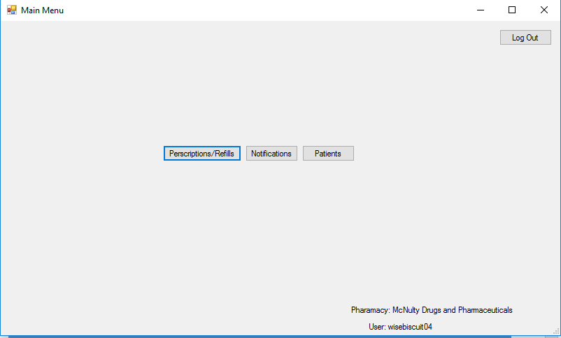

We will start by going through the Prescriptions/refills window.

Click the Prescriptions/Refills button.

## 

This shows the user all the prescriptions in the system for their pharmacy.

In this menu you can change the status of an incoming prescription/refill request.

To do this you need to click on the appropriate Prescription ID and select the new status you want to change it to.

You will know if the ID is selected if it is highlighted blue.

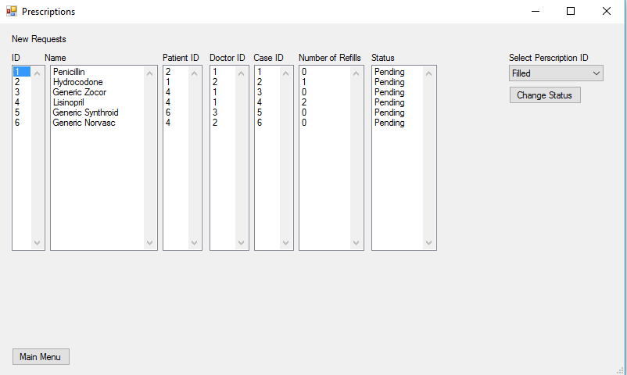

Finally click Change Status.

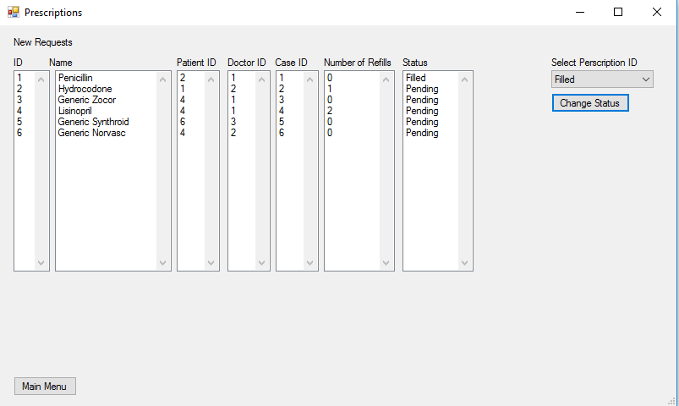

Now you can see that the prescriptions status has been changed.

Now click the Main Menu button and we will return to the Main Menu.

## Now we will move onto Notifications



Click the Notifications button in the Main Menu.

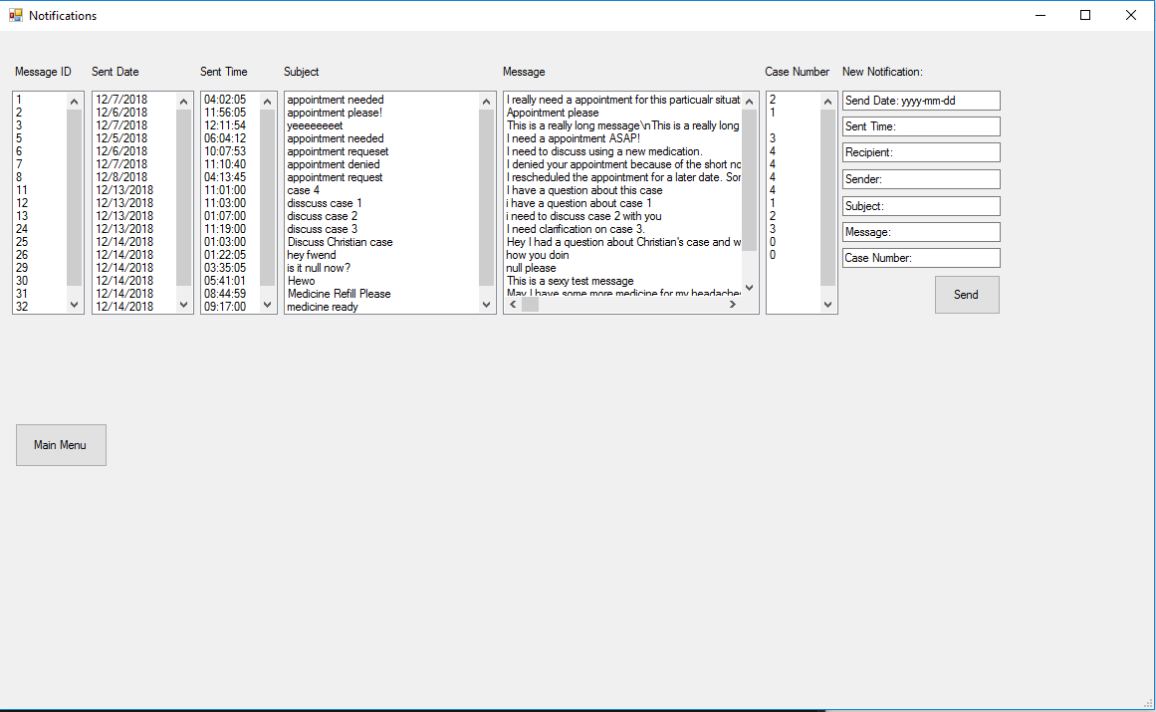

Here the pharmacy can see all of the notification in the system.

On the right side you can create a new notification in the system.

Fill in the information

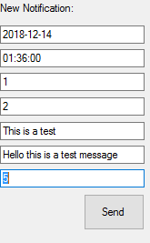

Once you click send the system will send the notification to the correct person.

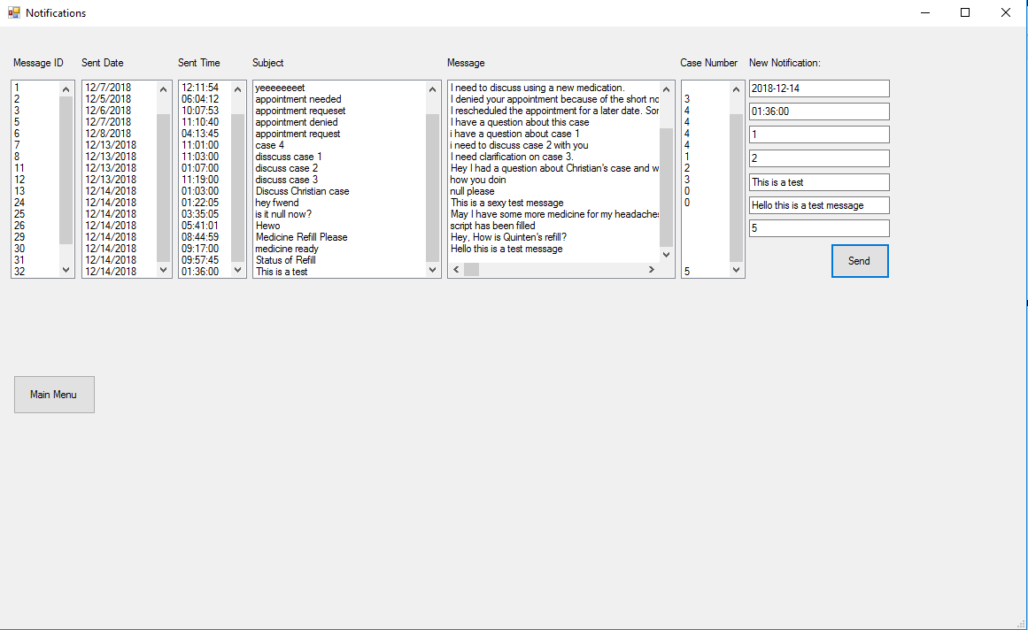

As you can see the page refreshed and you can now see our test message.

Now hit the Main Menu button and we will return to the main menu and finish with the last task.

## Finally, the Patients Tab



Now hit the Patients button and we will see the last functionality of the system.

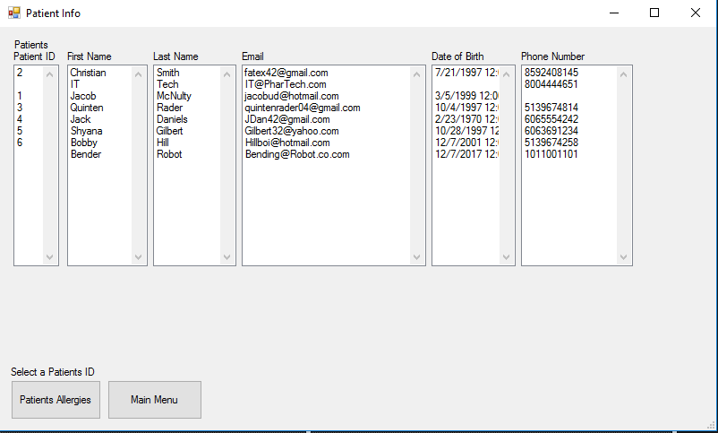

This menu shows all of the patients for a particular pharmacy.

To check a patient’s allergies, you need to select a patient’s ID and then click the Patient’s Allergies button.

You will know if the ID is selected if it is highlighted blue.

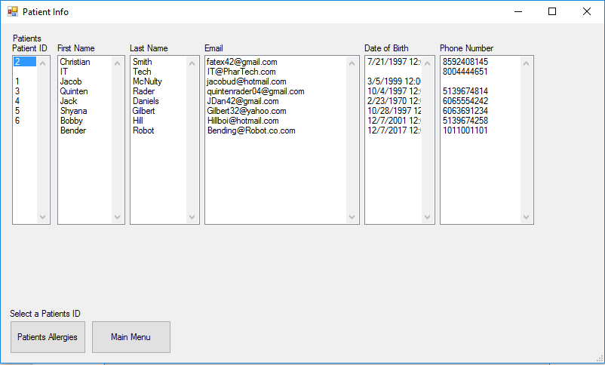

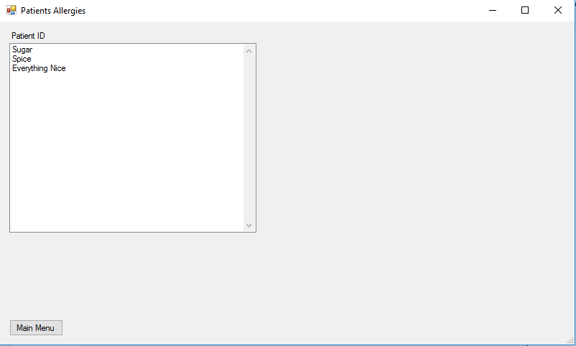

Now you can either close the Patients Allergies by clicking the X in the top right to take you back to Patient Info or you can click the Main Menu button to go back to the Main Menu.

## Logging out

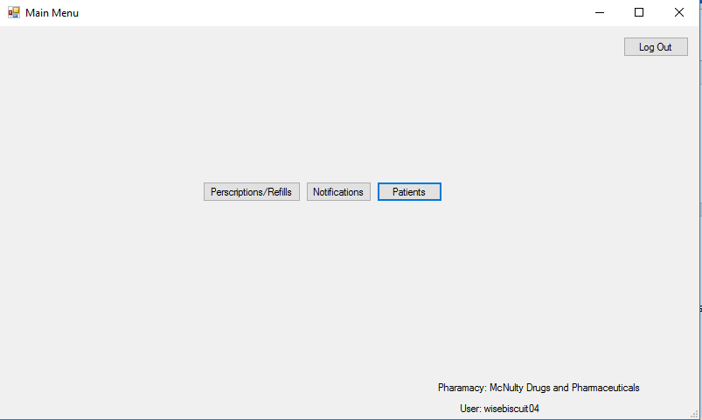

Once you are done using the system make sure to click the Log Out button to close the Main Menu and go back to the Log in screen.

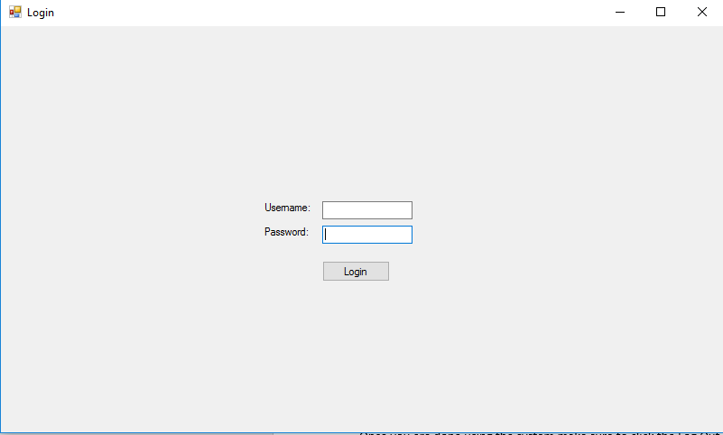

The system is now ready for someone else to log into and use the system.